**How to disable bash shell history in Linux**

Ido not want to save root users’ shell history. How do I force Linux or Unix server to forget bash shell history? How to disable bash shell history on Linux for the root user?  
  
The bash shell saves commands entered from terminal to a history file. You can recall the list of commands previously typed. The history command displays bash commands that you executed prior. These commands make up your command history. By default, history shows a numbered list of the 500 most recent commands, from earliest to most recent. The value of the HISTSIZE variable is used as the number of commands to save in a history list.

**How to display current history**

Just type the history command:  
history  
history | less  
history | more  
history | grep 'find'

**How to find out the number of commands saved in history**

Use echo command or printf command :  
echo "$HISTSIZE"  
OR  
printf "%d\n" $HISTSIZE  
Sample outputs:

1000

The value of the HISTSIZE variable indicates that the 1000 number of commands saved in a history list.

**Where are my bash history commands stored**

The history is initialized from the file named by the variable HISTFILE. The default is ~/.bash_history file. To view current settings run:  
echo "$HISTFILE"  
OR  
printf "%s\n" "$HISTFILE"  
Sample outputs:

/home/vivek/.bash_history

**How to disable BASH shell history on Linux or Unix**

You can remove HISTFILE shell variable by typing the following unset command:  
unset HISTFILE  
Add above line to the end of to a new /etc/profile.d/disable.history.sh file or ~/.bash_profile:  
echo 'unset HISTFILE' >> /etc/profile.d/disable.history.sh  
OR  
echo 'unset HISTFILE' >> ~/.bash_profile

**How to permanently disable bash history using set command**

Another option is to pass the +o history option to the set builtin command:  
set +o history  
Again add set +o history to the end of to a new /etc/profile.d/disable.history.sh file or ~/.bash_profile. See [how to set and use shell option in bash](https://bash.cyberciti.biz/guide/Setting_shell_options) for more info.

**How to clear the bash history**

Type the following command in your current session:  
history -c  
To delete a single command number 42 from history in Linux/Unix:  
history -d 42  
[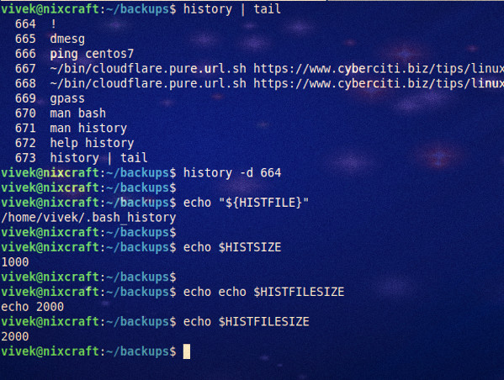](https://www.cyberciti.biz/media/new/faq/2018/01/How-to-disable-bash-shell-history-on-Linux.jpg)